Assignment 4

**Create a private bucket in AWS.Upload a file and check by presign url that you can access the file or not.**

**Steps for creating an AWS account:**

1. **Sign in.** Sign in as a root user. Provide username and password when prompted.
2. Search on the search bar **S3**. After that click on **bucket** in the **S3**.

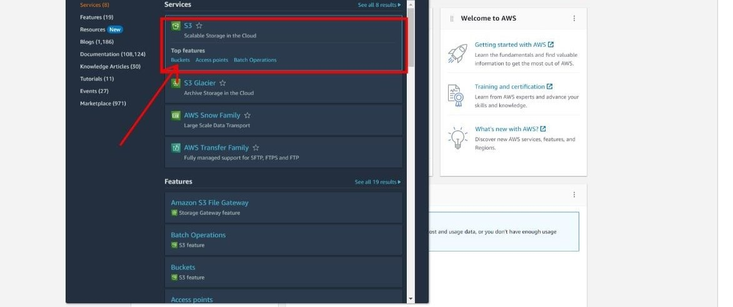

1. Now click on **Create bucket**.

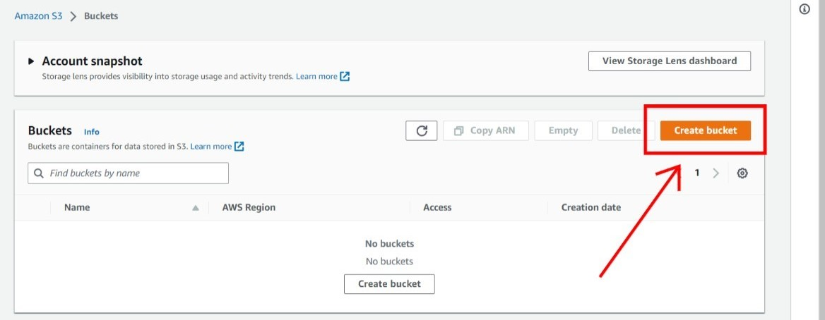

1. Give a **Unique** bucket name.

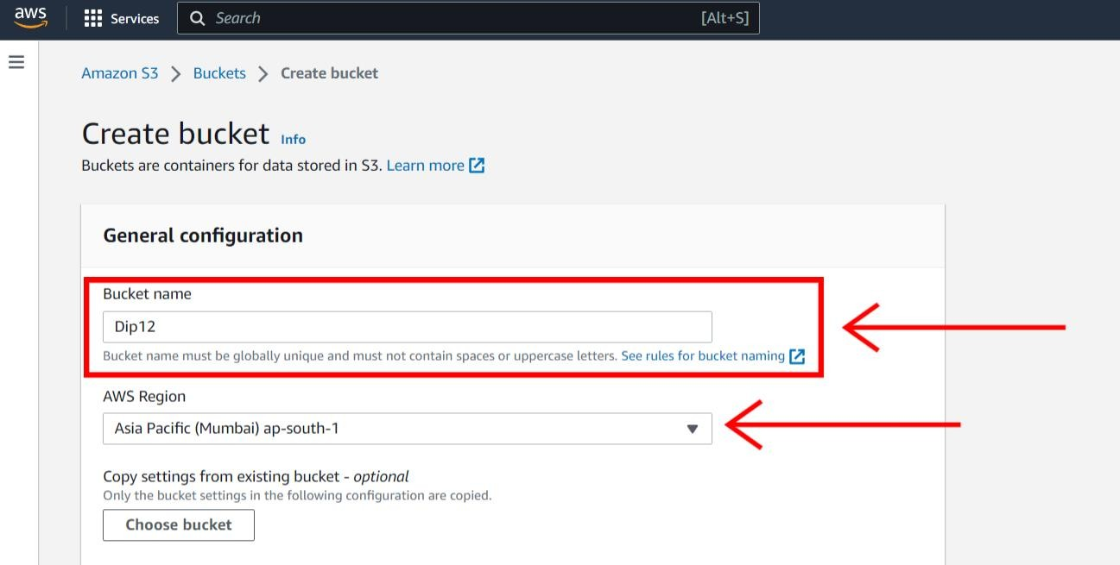

1. Now click on **ACLs disable**.

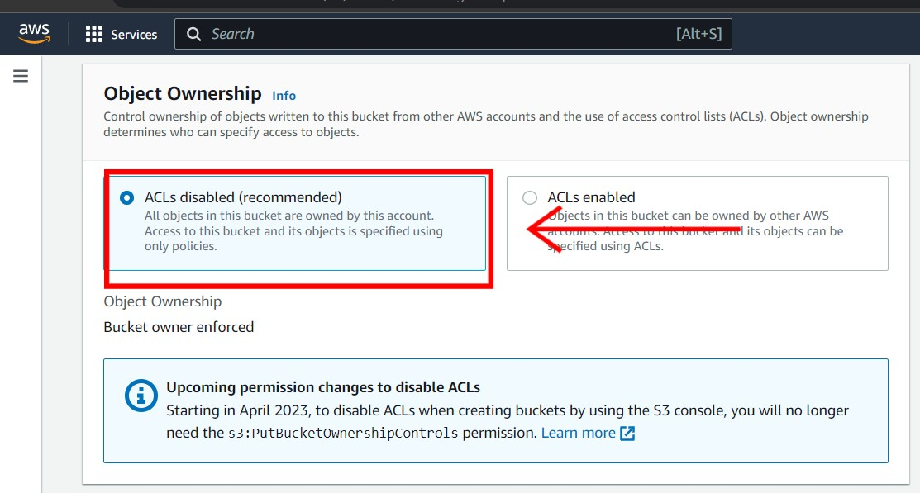

1. Now give the **Bucket versioning** as **disable.**

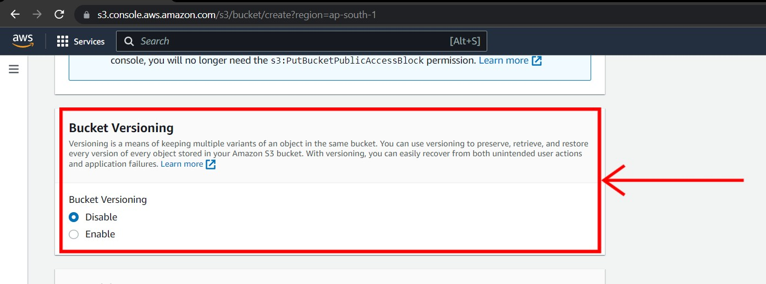

1. In the **Default encryption** section don’t change anything. Click on **create bucket**.

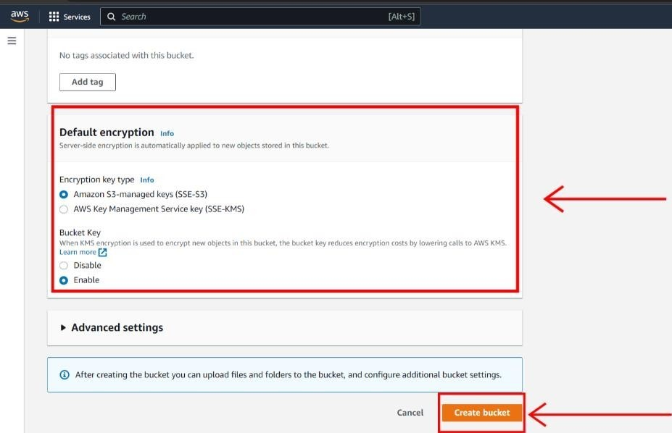

1. After your bucket has created click on the **bucket name**.

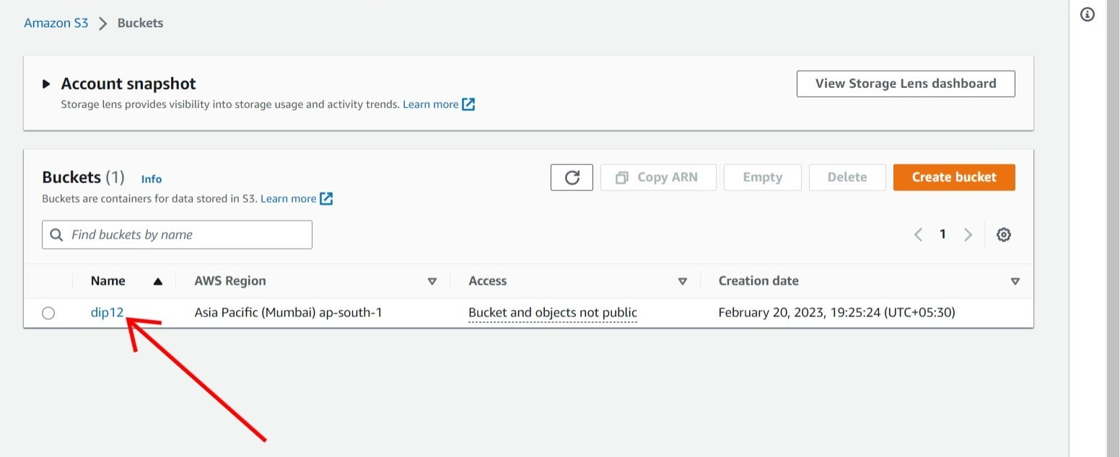

1. After that click on **upload** to upload **files or folders**.

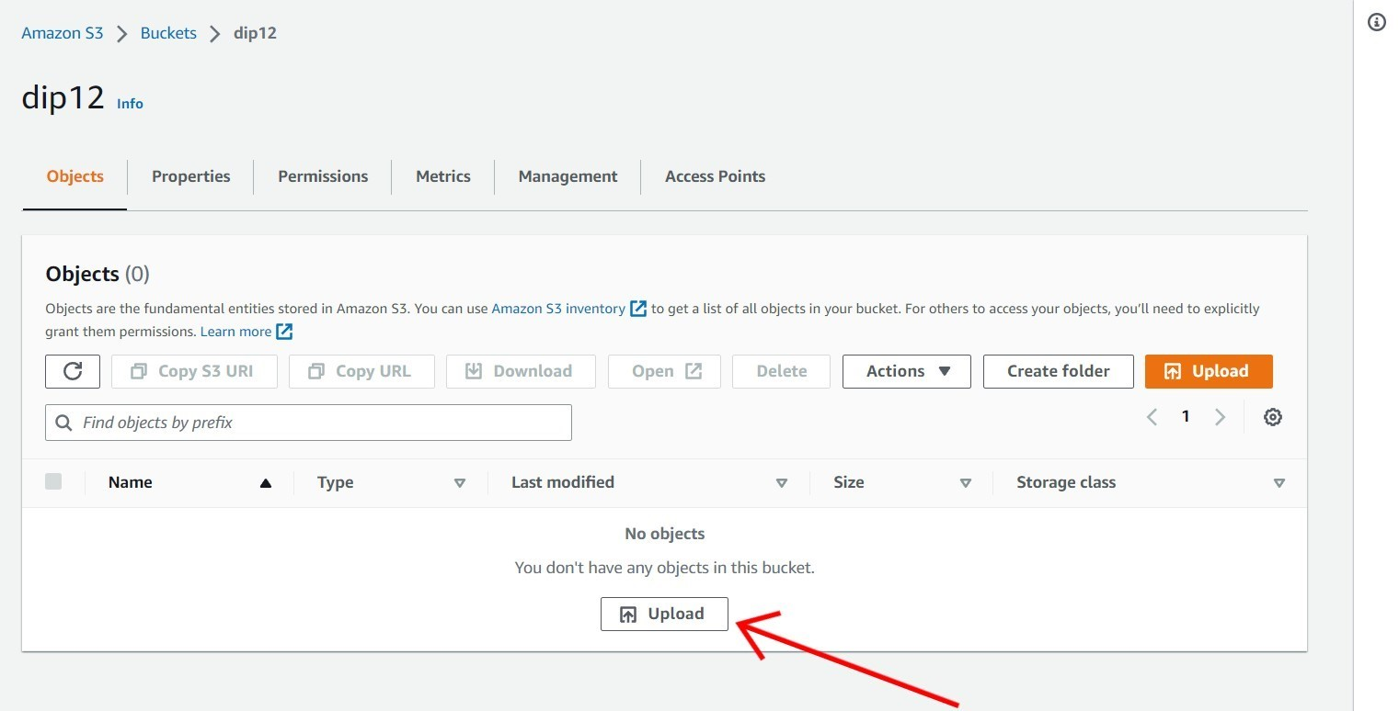

1. Click on **Add files** to add files or **Add folder** to add folders.

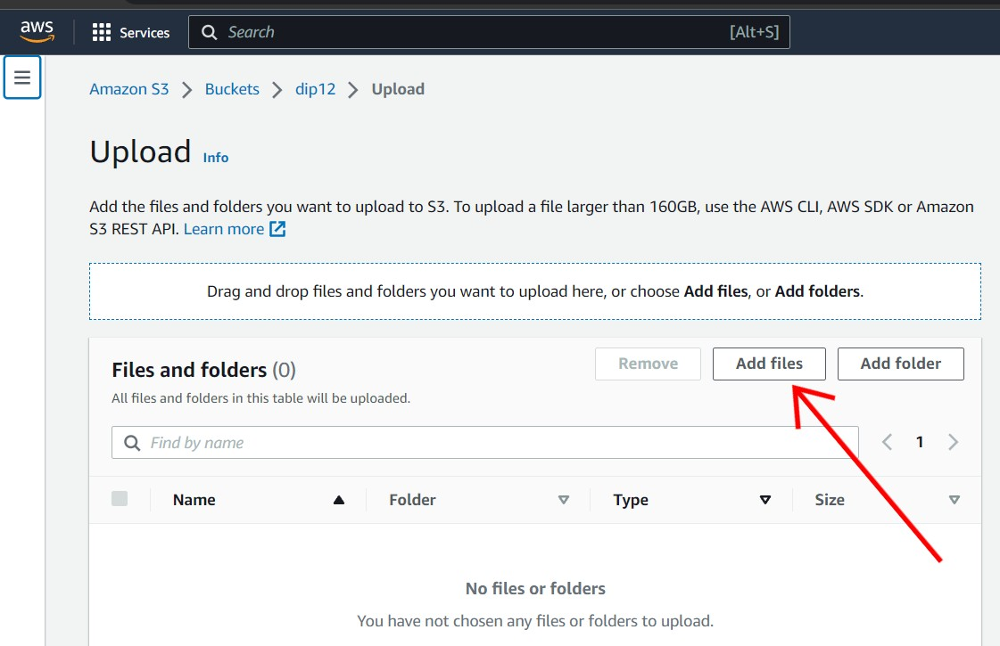

1. After that click on **upload**.

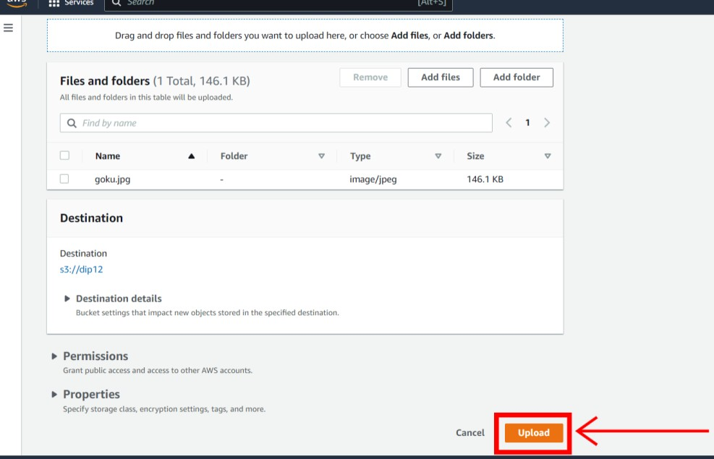

1. Now click **Close**.

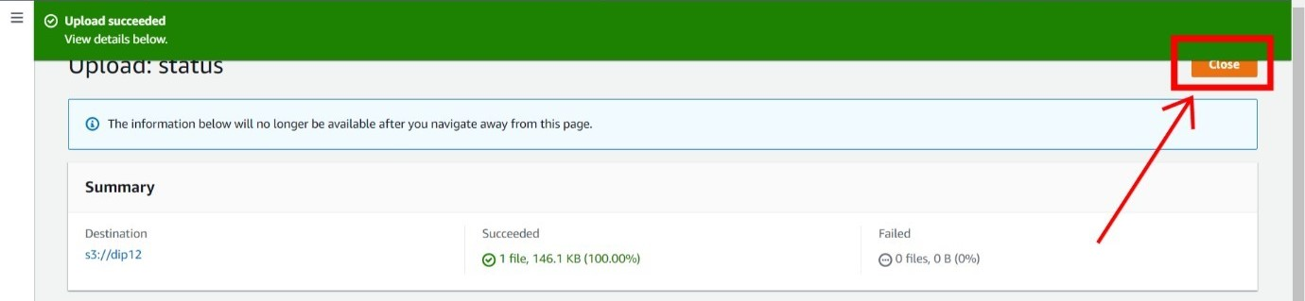

1. Click on the **object URL** to copy the URL so that we can see the file on web.

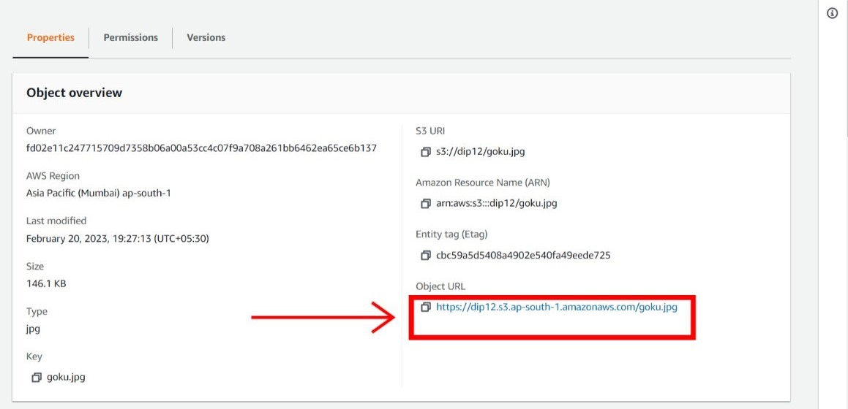

1. As we have not given the permission as public we can’t able to see the file.

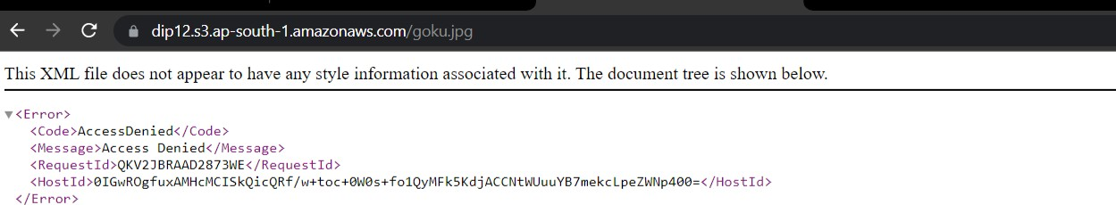

1. Now return back on AWS and click **object actions** and after that click on share with a **pre- signed URL**.

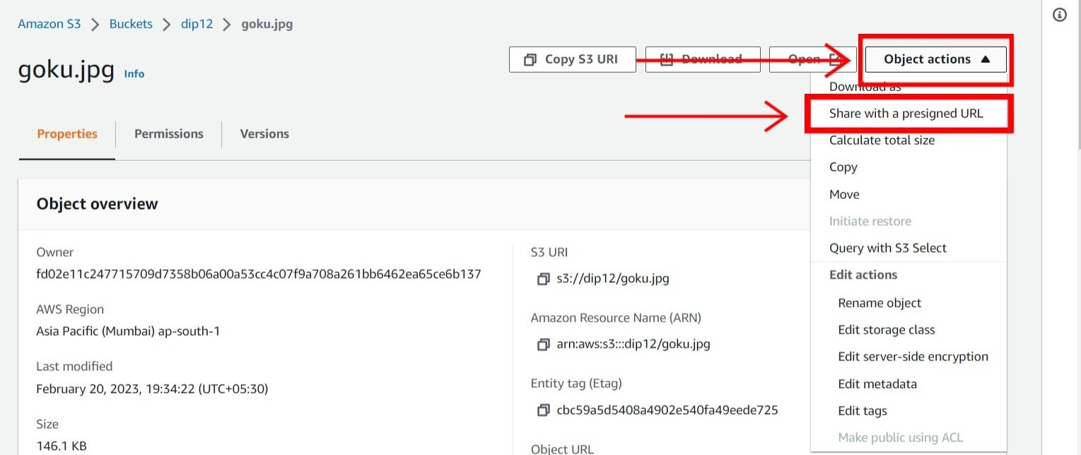

1. Select the **time interval** either in **minutes or hours** and give the time for how much you want the pre-signed URL to work. After that click **create pre-signed URL**.

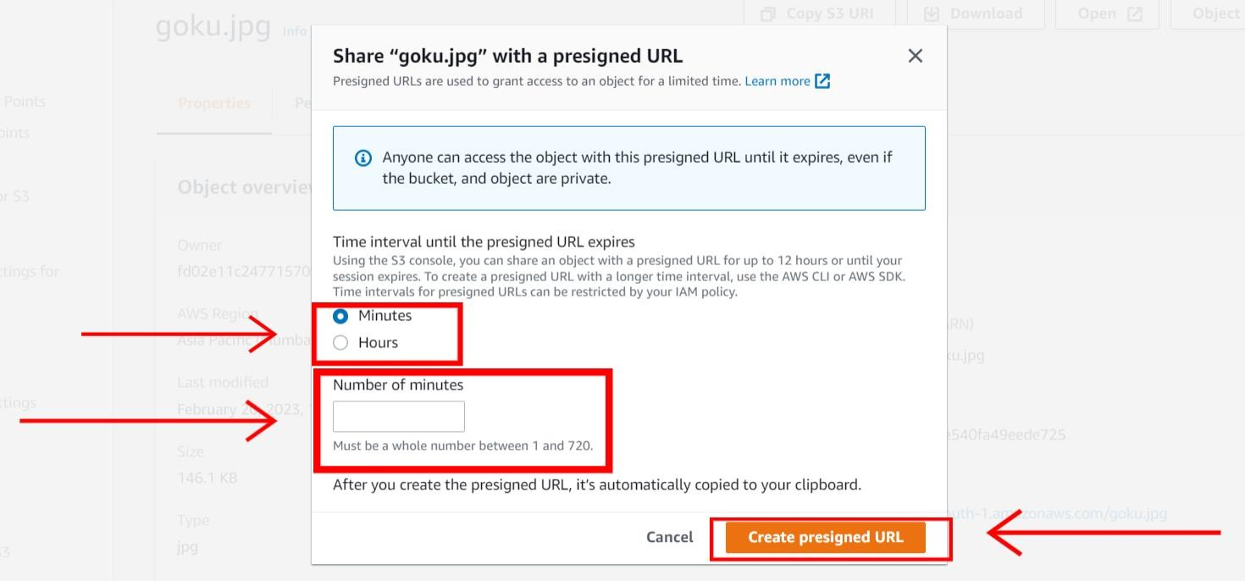

1. Now click on **copy pre-signed URL**.

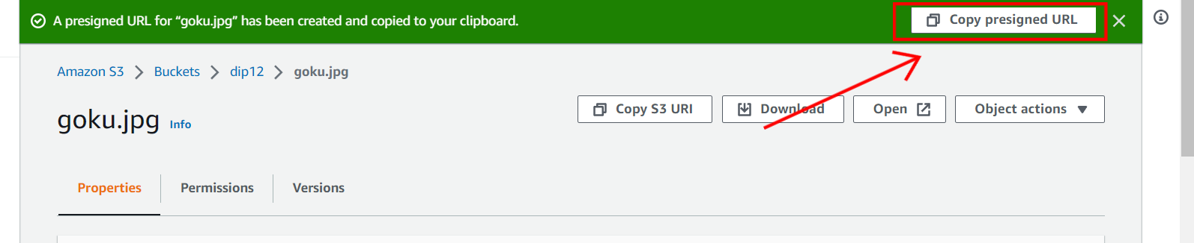

1. How paste the URL on a new tab and you can see that you are able to see the file which I have uploaded.

